CS-440-01 Data Communications
Name:
School:
Professor:
Date:

Project
In this section, you will explore a number of network-related DOS commands available in your computer.
A short description of the above commands follows:
- Arp: Displays and modifies the IP-to-Physical address translation tables used by the address resolution protocol (ARP). The arp command can be used to add a permanent entry in the Global Configuration mode. To remove an entry from the arp, a no form can be assed to the command.
Arp command displays and modifies the IP to physical address translation table used by the address resolution protocol. Arp has different associated options these include
-a option - This option displays the current ARP entries by interrogating the current protocol data. If the inet_addr is specified m the IP and the physical addresses for only the specified computer are displayed. If there are more than one network interface used ARP, entries for each ARP table are displayed
-v option -Displays current ARP entries in verbose mode. All invalid entries and entries on the loop-back interface will be shown.
Inet_addr - Specifies an internet address.
-N if_addr -Displays the ARP entries for the network interface specified by the if_addr
-d option - deletes the host specified by inet_addr. Inet_addr may be wild carded with * to delete all hosts.
-s option - adds the host and associates the internet address iner_addr with the physical address eth_adr. This physical address is given as 6 hexadecimal bytes separated by hyphens. The entry is permanent.
Ipconfig command
This is the windows IP configuration it associated options are:
/? This displays the help message
/all -this displays the full configuration information
/release- this releases the IPv4 address for the specified adapter
/realease6 – this releases the IPv6 address for the specified adapter
/flushdns – this commands purges the DNS resolver cache.
/registerdns- this command refreshes all DHCP leases and re-registers DNS names
/displaydns – Displays the content of the DNS Resolver cache.
/showclassicid – displays all the content of the dhcp class IDs allowed for adapter
/showclassicid6- this displays all the IPv6 DHCP class IDs allowed for adapter.
/setclassicid6 – this modifies the IPv6 DHCP class id.
- Netstat: Displays protocol statistics and current TCP/IP network connections. The netstat command is commonly used to display information on how the computer is used in communicating with other network devices or computers. It can show individual network connection details or statistics as well as trouble statistics. The netstat command is available in most of the windows e.g. windows XP.

- Nslookup: Studies DNS infrastructure. The utility gives the user command line the access to the DNS system. The user is also able to specify the different types of queries. It is a develop package BIND for the UNIX-based systems. In testing the command,
C: \> nslookup esds.co.in
esds.co.in – replace with your domain name.
The result should be;
Server: ns1.hhhhhhhhhh.hhh Address: hh.hh.hh.hh Non-authoritative answer: Name: esds.co.in Address: 115.XXX.XXX.10
This command displays the protocol statistics and current TCP/IP network connection. Netstat has the following associated command these include
-a -this command displays all the connections and the listening ports
-b –displays the executable involved on creating each connection or listening port .in some cases well known executable host multiple independent components, and in these cases the sequence of component involved in creating the connection or listening port is displayed. In this case the executable name is in [] at the bottom, on top is the component it called, and so forth until TCP/IP was reached. Note that this option can be time-consuming and will fail unless you have sufficient permissions.
-e –this command option displays the Ethernet statistics
-f -this command option displays the Fully Qualified Domain Names (FQDN) for foreign addresses.
-n –this command option Displays addresses and port numbers in numerical form.
- Ping: Checks system availability by using the ICMP Echo Request/Response messages.
ICMP is used by network administrators to debug the networks it is used in low protocol keys and in denial of service attacks. It is used as part of the all attacks on systems. ICMP is similar to the UDP and TCP packets and can be used in filtering system.
Checks system availability by using the ICMP Echo Request/Response messages. The ping has the following options.
-t this option command pings the specified host until it stopped
- a – this command resolves the addressed to hostname
- n count –this option command set the number echo request to send
-l this command sends the buffer size

- Tracert: Finds the hop sequence from source to destination.
Tracert is used in determining the path in which a packet is used so as to get a destination. This utility is usually attached to the OS for example, the Microsoft Winoes, Linux.
Finds the hop sequence from source to destination
Tracert command has the following option commands
-d - Do not resolve addresses to hostnames.
-h maximum_hops -Maximum number of hops to search for target
-j host-list -loose source route along host-list (IPv4-only).
-w timeout -Wait timeout milliseconds for each reply.

- Route: Displays and modifies entries in the routing table.
All the computers run on TCP/IP routing decisions which are controlled by the IP routing table. This command displays and modifies entries in the routing table. The command has the following option commands
-f - Clears the routing tables of all gateway entries. If this is used in conjunction with one of the commands, the tables are cleared prior to running the command.
-p -When used with the ADD command, makes a route persistent across boots of the system. By default, routes are not preserved when the system is restarted. Ignored for all other commands, which always affect the appropriate persistent routes.
The route print is used as the command prompt, examples of IP route tables include;
  - A computer which is running windows server 2003 OS
  - Default gateway: 10.0.0.1
  - IP address 10.0.0.0169
Question 1
The ping of www.twitter.com at 100bytes
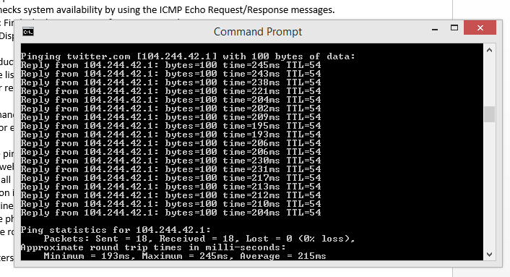

The ping of www.twitter.com for a thousand bytes
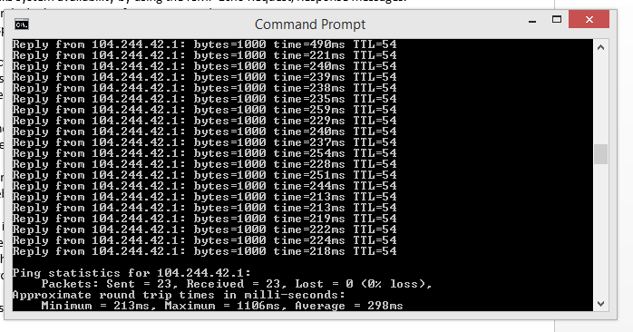

Question 2
Tracert of www.facebook.com
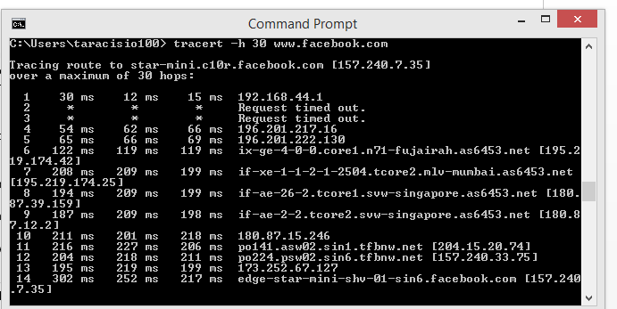
Tracert of www.goal.com
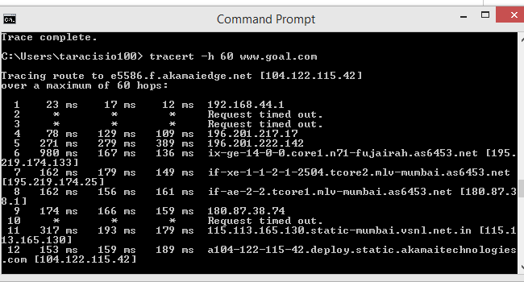

Question 3
Determine the domain name of my IP address
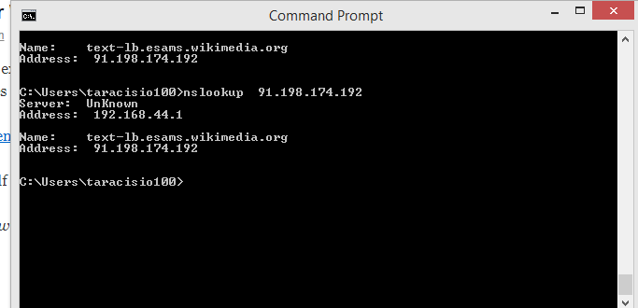

Question 4
Find the physical address of your Network Interface Card.
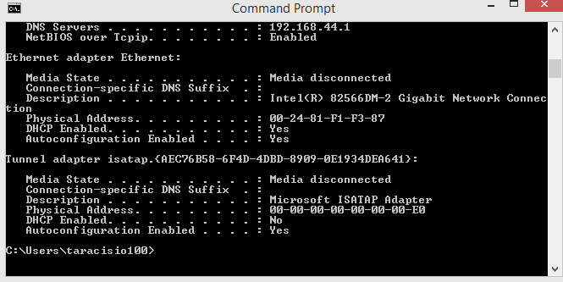

Queston5
Print the routing table of your computer and compare it to routing tables in other computers
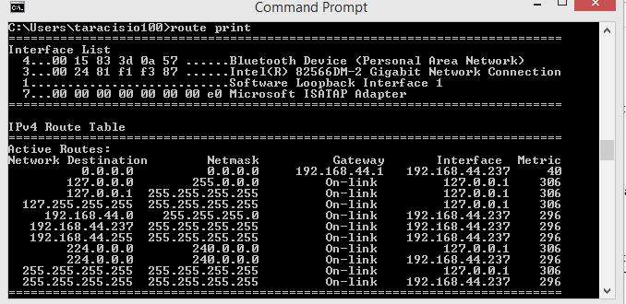

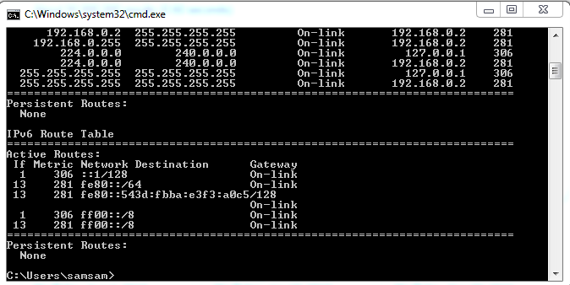
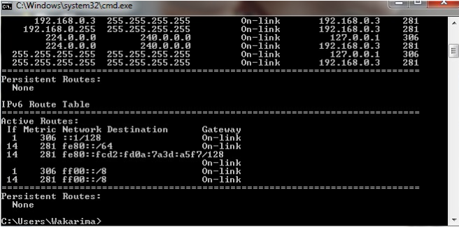

Question 6
Display all the active connections of your computer.
